Oracle Retail Predictive Application System: Ranging System

Range products after the event has been created in Range Control

Event has to be created and should be in ready status in Range Control

Double click the RPAS icon

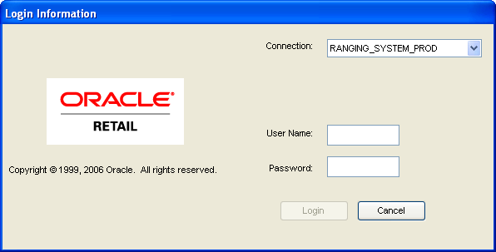 | Authenticate using the Login ID provided by your admin  cespino/cespino
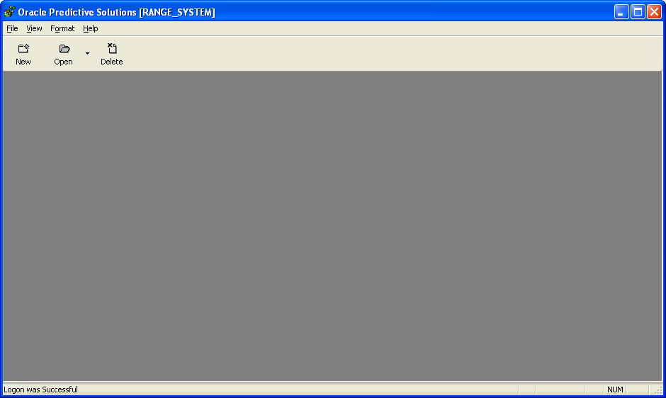 | On the upper left window, click on the NEW icon
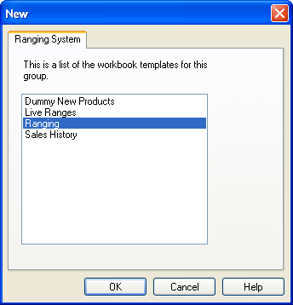 | Select Ranging then click OK
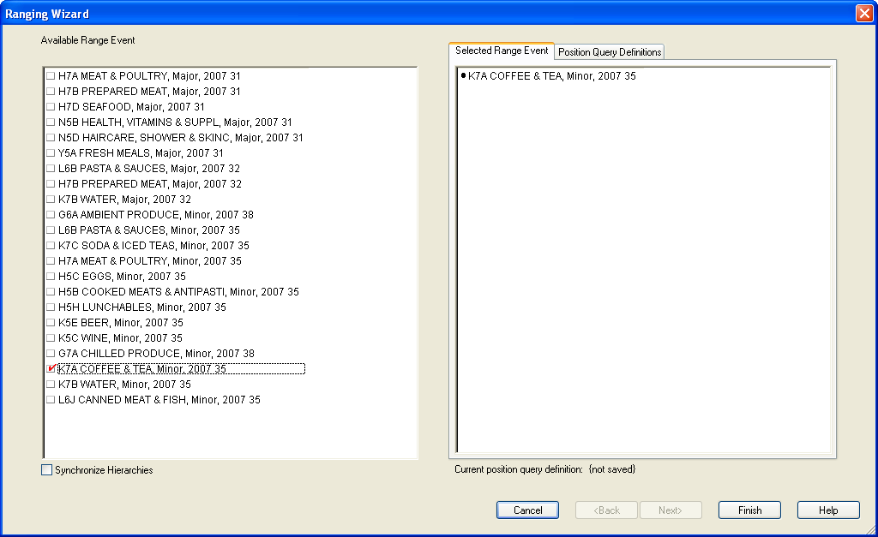 | Select the Event that you want to Range  Once you’ve selected the range that you selected will show up on the right frame of the window  You can only Range 1 event at a time  Click Finish button when you’re done
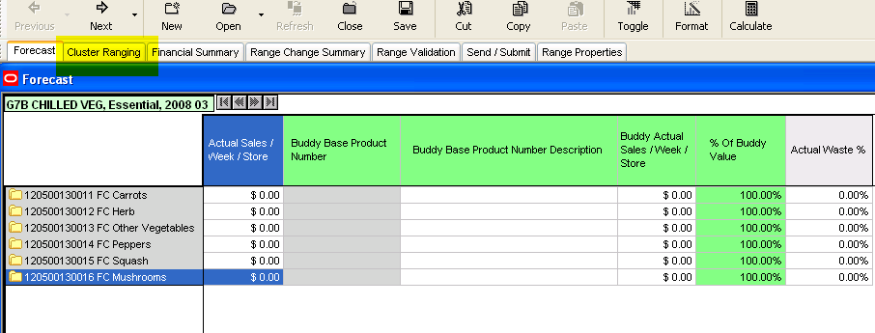 | Click on Cluster Ranging  ***** This is new from Kandice ***  *** Feb 27 ****
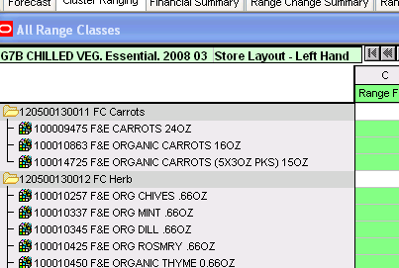 | Right click on the box and select “Subclass As Is”  ***** This is new from Kandice ***  *** Feb 27 ****
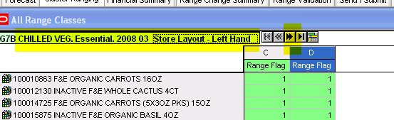

This is the Cluster info
As you can see from above it shows the Left Hand Store Layout
With C and D clusters

Click on the >> Right hand arrow

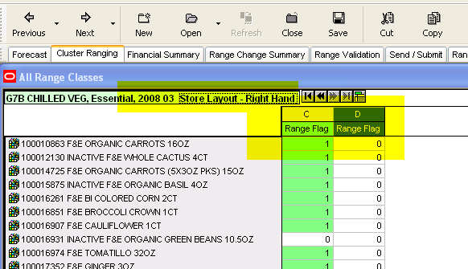

Right click on the arrow and the
Right Hand store layout will appear
It has a C cluster

***** Where is the data coming from?
RMS?
When does the data get fed? Nightly RMS feed? *****b
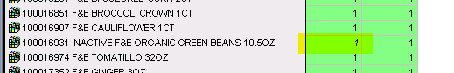

When you update the column with a “1” it will be italic, only when you click “Calculate” will it return to a normal font.

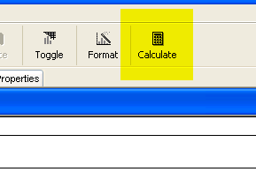
Click on Calculate

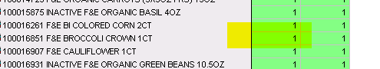

The font will return to normal after you click calculate

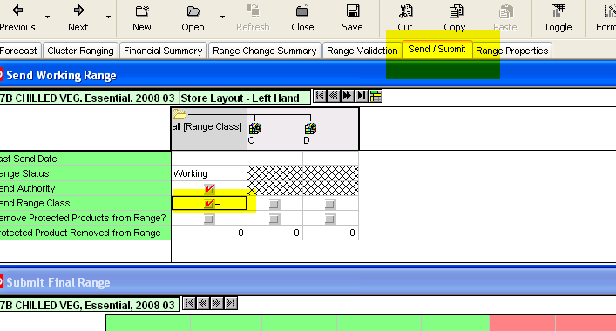

Click Send /Submit
Click Send Range Class

Click Calculate

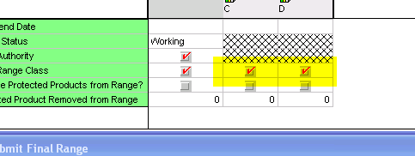

After clicking Calculate
The “C” and “D” clusters will also be checked

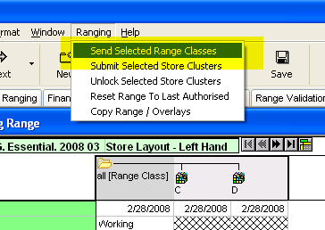

Select Ranging
Click “Send Selected Range Classes”

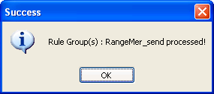 | A window will pop-up to confirm that the Store Clusters were Sent successfully  Click OK
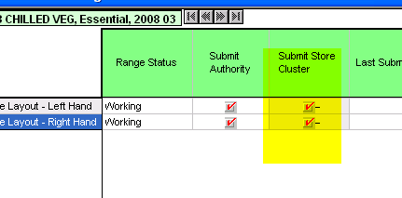

Select the boxes to submit store cluster

Click Calculate

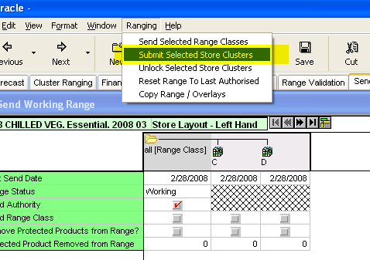

Select Ranging
Select Submit Selected Store Clusters

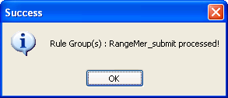

Window will appear to validate that it has been submitted.

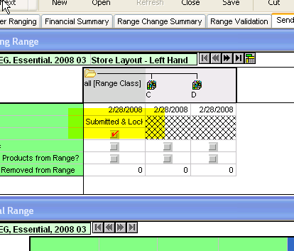

Submitted and Locked will validate that it has been submitted.

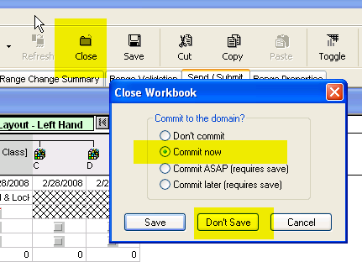

Click Close
Select Commit Now
Click Don’t Save

And you’re done!!!!!

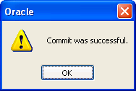

Will confirm

Session with Kandice on Feb 27th.

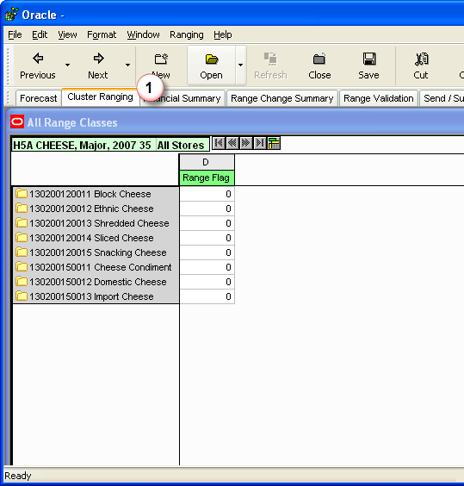 | ( 1 ) Click on Cluster Ranging tab to start Ranging

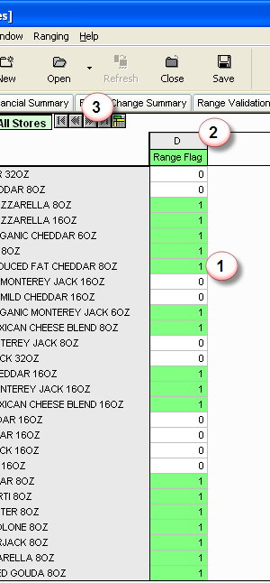 | Select the products that needs to be ranged  ( 1 ) On the left column, identify the products that you need to range. Enter 1 in column D for products that you want to be ranged, enter 0 for products that you don’t want to be ranged  ( 2 ) The D column indicates the Range Class, for certain Display Groups there could be 2 Range Classes defined  Range class are as follows:  A = 1 fixture  B = 2 fixtures  C = 3 fixtures  D = 4 fixtures  E = 5 fixtures  F = 6 fixtures  G = 7 fixtures  H = 8 fixtures  I = 9 fixtures  J = 10 fixtures  ( 3 ) Certain Display Groups could have multiple clusters, once you’re done ranging your current cluster select the button to work on the next cluster. If the icons are shaded then you don’t have any store clusters in this Display Group.

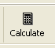 | Once you’re done ranging, click on the calculate button on the far right of the window
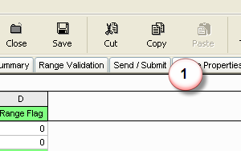 | Click Send / Submit tab
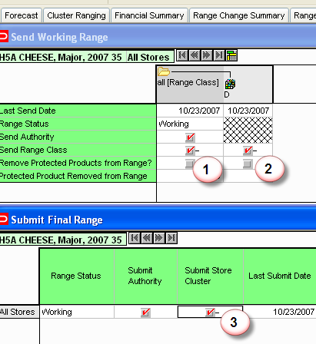 | Click both Send range Class Columns  ( 1 ) All Range Class column  ( 2 ) D column  ( 3 ) Click the All Stores box under the Submit Store column
 | Click on the calculate button on the far right of the window
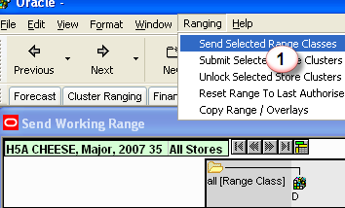 | From the menu  ( 1 ) Select Ranging then click Send Selected Range Classes

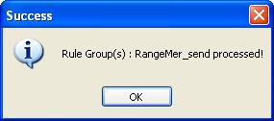 | A pop-up window will confirm that the Range and Cluster has been processed  Click OK
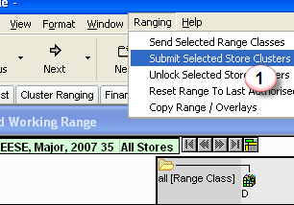 | From the menu  ( 1 ) Select Ranging then click Submit Selected Store Clusters
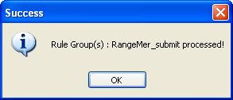 | A pop-up window will confirm that the Range and Cluster info has been processed  Click OK
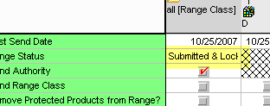 | The range status has been updated to Submitted & Locked
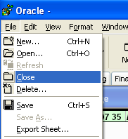 | To exit out of the Application  Select File then Close
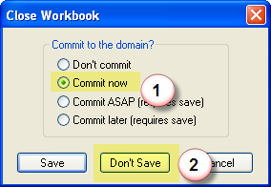 | A window will prompt you  ( 1 ) Select Commit Now  * Commit the changes to the database  Then  ( 2 ) Don’t Save  * By default it will try to save to your local machine, by selecting don’t save it will save it to the database
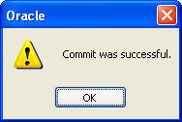 | A window will prompt you that the changes you’ve done are now saved to the database  Click OK
The application will return you back to the main application window, you can exit from here.

If you need to range more Display Groups, select the NEW icon.

